Living the D-Life
  - —Disciple-Making. Anytime. Anywhere.
  - Issue Date

Discipleship groups OF three to five people can meet anytime and anywhere |  | upcoming D-Life Training

Disciple-making is not a program; it’s a lifestyle. This is a big truth. Jesus said, “Follow Me and I will make you fishers of men” (Matt. 4:19). Clearly, this was no call to join a discipleship program but an invitation to a lifestyle of disciple-making. According to Jesus, this lifestyle is the supreme purpose of every believer. You cannot be a true follower of Jesus without becoming a fisher of men.
Common Misconceptions
There are some common misconceptions in today’s church about disciple-making. Some think it is evangelism. It means having gospel conversations and seeking to lead others to Christ. Certainly, this is a vital part of disciple-making. But making converts is not the same as making disciples. You can do evangelism without being a disciple maker, but you cannot be a disciple maker without doing evangelism.
Others think disciple-making is Bible study. It involves great studies where people go deep into the Bible. Again, this is a vital part of disciple-making but there is a problem. Many participate in great Bible studies and then want to know when is the next one and the next one and the next one. We are making great Bible learners but not disciple makers.
Christ’s Model
With no buildings or budgets, Jesus launched a disciple-making movement that exploded upon the world. In comparison, the church today has discipleship programs, but few disciple-making people. We must exchange our misconceptions about discipleship for Christ’s model of disciple-making.
Jesus made disciples who made disciples; He didn’t make any other kind. Apart from multiplication, there is no real discipleship. Multiplication is the key to reaching our world for Christ. However, most churches today lack a simple process for equipping believers to make and to multiply disciples. For the most part, we are attempting to reach the world by addition and we simply cannot keep pace.
By reading the Gospels, we learn there are six practices of disciple-making that Jesus modeled for us with His discipleship group. These include: 1) fellowship, 2) teaching, 3) prayer, 4) ministry, 5) multiplication, and 6) accountability.
In a D-Life Boot Camp, we will unpack these six practices and train you to use them in living a true lifestyle of disciple-making.

Six Practices of Disciple-Making
by Bill Wilks
Join us for D-Life Boot Camp…
Put Church Name Here
City, State
Day, Date
Time
(Light Dinner OR Lunch Included)
Training for a lifestyle
of disciple-making.

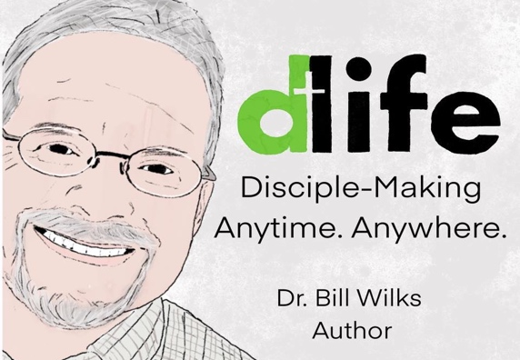
Dr. Bill Wilks is the Founder of D-Life and Lead Pastor of NorthPark Church in Trussville, AL. He has a Doctor of Ministry degree from Southwestern Baptist Theological Seminary and often serves as an Adjunct Professor at the New Orleans Baptist Theological Seminary extension in Birmingham, AL. Dr. Wilks is a passionate disciple maker. Through D-Life, he and his wife, Rondie, have traveled the country training thousands of believers for a lifestyle of disciple-making. For more: www.livethedlife.com.

